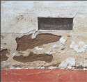1) Preliminary Inspection - Upon our initial visit, we walk around the home and point out areas of special concern or deteriorated areas that will need stucco/crack repair or wood replacement.
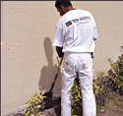2) Trenching - In areas where the foundation of the home is exposed to soil, we trench 6-8″ inches to reach below ground level and ensure no moisture seeps up into the substrate. Once primed and coated the areas are refilled and secure from future costly water damage.
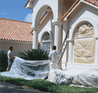3) Masking/Covering – Then, plants, foliage, windows, pools and surrounding personal property is masked covered and protected. This eliminates overspray from occurring and leaves a clean professional looking job.

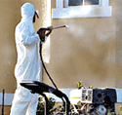4) Hydrowashing/Sanding – Next, a high pressure/power hydrowashing is performed (3500 minimum PSI up to 4200 PSI). This ensures that all loose, scaling, bubbling or peeling old paint and/or dirt is efficiently removed from the substrate/surface which CoolLife is being applied to. Wood surfaces are professionally scraped, sanded and feathered to industry standards and manufacturers recommendations.
This step also exposes cracks, stucco decay and other common stucco defects which will be mended and patched. Most importantly, we are seeking a clean and sound substrate/surface so that when CoolLife is applied it permanently fuses itself to the walls.
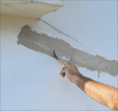5) Patch and Repair – The CoolLife System designates specific products that are to manufacturer’s specifications. The use of LifePaint for stucco imperfections and FLEX-PATCH™ for structural and hairline cracks is critical for the CoolLife system products applied to work together to create the system that will protect your home for years to come.
The CoolLife process includes the patching, repairing and replacement of all imperfections such as cracks, broken corners, decayed foundation stucco, bubbling and missing stucco areas or holes. All wood is inspected for rotting, decay and/or termite damage and any unstable wood is replaced and is to be sealed.
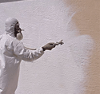6) CoolLife Primer/Sealer – ‘The First Coat of Armor’ – The CoolLife process is a full coverage two layer application; similar to an epoxy one cannot/will not be effective without the other.
The CoolLife Primer is to be applied (as per manufacturers recommendations) to every square inch of surface that will be coated.
CoolLife Primer has two distinctive textures, Smooth and Textured. The CoolLife Smooth Primer is fantastic on wood, siding, eaves and smooth plaster walls. The CoolLife Textured Primer is designed to created uniformity on walls that require a lot of patching and repairing in that it actually resurfaces the sand finish that is so prevalent in Southern California stucco homes.
CoolLife Primer must be allowed to cure (dry) for 24-48 hours.
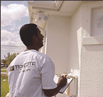7) Primer Coat Inspection – The entire substrate is inspected to ensure the surface is coated evenly and ready for the next and very important step.
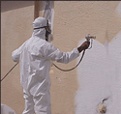8) CoolLife Finish Coat – ‘The Second and Final Coat of Armor’ Applied with special machinery that along with the primer coat creates a protective barrier from the elements that commonly effect painted surfaces.
The CoolLife Finish Coat leaves you with an eggshell sheen (approximately 11%) which is easy to clean, won’t allow moisture to penetrate, can expand and contract over cracks, and will keep the inside cooler while greatly reducing your cooling costs.
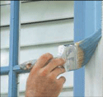9) Trim - Wood eaves, fascia and trim are detailed with brushes using the specially formulated Trim. The same heat reflective properties found in CoolLife are also found in Trim.
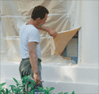10) Clean-Up - At Elite Energy Improvements, the CoolLife Process includes a thorough and complete clean up and hauling of all job related debris. If desired, extra ‘touch-up’ paint can be left for future use.

